UNIT CONVERSION APPPLICATION REPORTS 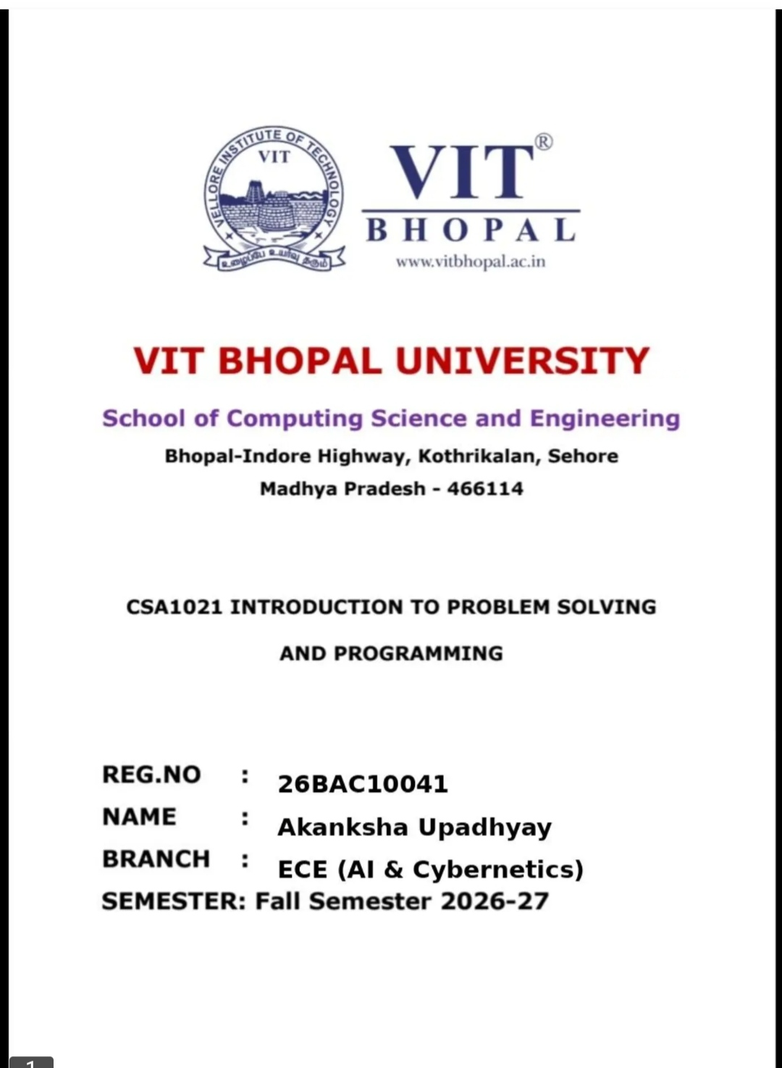
﻿

PAGE 2 — CERTIFICATE

CERTIFICATE
This is to certify that Akanksha Upadhyay, Registration No. 26BAC10041, student of ECE (AI & Cybernetics), has successfully completed the project entitled “Unit Conversion Application” as a part of the academic requirements for the session 2026–27.﻿
The project has been completed under the guidance of the concerned faculty member. The work presented in this report is based on the implementation of a Python-based unit conversion application.﻿

PAGE 3 — DECLARATION

DECLARATION
I hereby declare that the project entitled “Unit Conversion Application” has been prepared by me as part of my academic work.﻿
The project is developed using the Python programming language. I have made sincere efforts to understand the concepts used in the project and implement them correctly.﻿
I also declare that the information presented in this report is prepared for academic purposes.﻿
Name: Akanksha Upadhyay﻿
Registration No.: 26BAC10041﻿

PAGE 4 — ACKNOWLEDGEMENT

ACKNOWLEDGEMENT
I would like to express my sincere gratitude to my teachers and faculty members for their valuable guidance and support during the development of my project, “Unit Conversion Application.”﻿
I am thankful to my college for providing me with the opportunity to work on this project. This project helped me improve my understanding of Python programming and its practical applications.﻿
I would also like to thank my friends and family for their encouragement and support throughout the completion of this project.﻿
Finally, I am grateful to everyone who directly or indirectly helped me in completing this project successfully.

PAGE 5 — ABSTRACT

ABSTRACT
The Unit Conversion Application is a Python-based application developed to perform different types of unit conversions quickly and easily.﻿
The application provides a menu-driven interface where the user can select a particular conversion category, enter the required value, and obtain the converted result.﻿
The project includes several categories such as Length, Weight, Temperature, Time, Area, Volume, Speed, and Digital Storage.﻿
The main purpose of this project is to demonstrate the practical implementation of Python programming concepts such as variables, input/output, conditional statements, loops, functions, and mathematical calculations.﻿
The application is simple, useful, and suitable for students and beginners who want to understand programming through a real-world application.

PAGE 6 — INTRODUCTION

INTRODUCTION
Unit conversion is an important part of mathematics, science, engineering, and everyday life. Different countries, industries, and applications may use different units to represent the same physical quantity.﻿
The Unit Conversion Application provides a simple way to convert a value from one unit to another. It is developed using Python and uses a menu-driven approach to make the application easy to operate.﻿
The user can select a conversion category and provide the required input. The program then applies the appropriate conversion formula and displays the result.﻿
This project demonstrates how programming can be used to solve practical problems and perform calculations efficiently.

PAGE 7 — OBJECTIVES

OBJECTIVES OF THE PROJECT
The main objectives of the Unit Conversion Application are:
- To develop a simple unit conversion application using Python.
- To provide multiple categories of unit conversion.
- To reduce the need for manual calculations.
- To provide quick and accurate conversion results.
- To understand the practical use of Python programming.
- To implement conditional statements and loops.
- To understand user input and output handling.
- To develop a simple menu-driven application.
- To improve problem-solving and programming skills.
- To create a useful beginner-level real-world project.

PAGE 8 — TECHNOLOGIES AND TOOLS USED

TECHNOLOGIES USED

1. Python
Python is a high-level, interpreted programming language. It is easy to understand and widely used for developing different types of applications.﻿
Python is used in this project to implement the conversion logic and user interface.

2. Visual Studio Code
Visual Studio Code is used as the development environment for writing, editing, and running the Python program.

3. GitHub
GitHub can be used to store and manage the project source code online. It also helps in maintaining and sharing the project repository.

4. Operating System
The application can be executed on a computer system with Python installed.

PAGE 9 — FEATURES OF THE APPLICATION

FEATURES
The Unit Conversion Application provides the following features:

1. Length Conversion
Converts units such as metre, kilometre, centimetre, millimetre, inch, foot, and mile.

2. Weight Conversion
Converts units such as kilogram, gram, milligram, pound, and ounce.

3. Temperature Conversion
Converts values between Celsius, Fahrenheit, and Kelvin.

4. Time Conversion
Converts seconds, minutes, hours, days, and other time units.

5. Area Conversion
Converts square metre, square kilometre, square centimetre, acre, hectare, etc.

6. Volume Conversion
Converts litre, millilitre, cubic metre and other volume units.

7. Speed Conversion
Converts kilometre per hour, metre per second, mile per hour, etc.

8. Digital Storage
Converts units such as byte, kilobyte, megabyte, gigabyte, and terabyte.

PAGE 10 — WORKING OF THE APPLICATION

WORKING / METHODOLOGY
The application follows a simple step-by-step process:﻿
Step 1: Start the program.﻿
Step 2: Display the main conversion menu.﻿
Step 3: Ask the user to select a conversion category.﻿
Step 4: Display the available units for the selected category.﻿
Step 5: Ask the user to enter the value to be converted.﻿
Step 6: Apply the appropriate conversion formula.﻿
Step 7: Display the converted result.﻿
Step 8: Allow the user to perform another conversion or exit the program.

Basic Flow
START → SELECT CATEGORY → SELECT UNITS → ENTER VALUE → CALCULATE → DISPLAY RESULT → CONTINUE/EXIT

PAGE 11 — ALGORITHM

ALGORITHM
- Start the program.
- Display the title of the application.
- Display the list of conversion categories.
- Take the user's category choice as input.
- Check the selected category.
- Display the corresponding units.
- Take the source unit and target unit.
- Take the numerical value from the user.
- Apply the required conversion formula.
- Display the converted value.
- Ask whether the user wants to perform another conversion.
- If yes, return to the main menu.
- If no, terminate the program.
- End.

PAGE 12 — FLOWCHART

FLOWCHART OF THE PROJECT
Draw the following flowchart manually using boxes and arrows:﻿
START﻿
↓﻿
Display Main Menu﻿
↓﻿
Select Conversion Category﻿
↓﻿
Select Source & Target Units﻿
↓﻿
Enter Value﻿
↓﻿
Apply Conversion Formula﻿
↓﻿
Display Converted Result﻿
↓﻿
Another Conversion?﻿
↙ ↘﻿
YESNO﻿
↓ ↓﻿
Main MenuEND

PAGE 13 — CONVERSION FORMULAS

IMPORTANT CONVERSION FORMULAS

Length
1 metre = 100 centimetres﻿
1 kilometre = 1000 metres﻿
1 foot = 0.3048 metre﻿
1 inch = 0.0254 metre

Weight
1 kilogram = 1000 grams﻿
1 gram = 1000 milligrams﻿
1 pound ≈ 0.453592 kilogram

Temperature
Celsius to Fahrenheit:﻿
°F = (°C × 9/5) + 32﻿
Fahrenheit to Celsius:﻿
°C = (°F − 32) × 5/9﻿
Celsius to Kelvin:﻿
K = °C + 273.15

Time
1 minute = 60 seconds﻿
1 hour = 60 minutes﻿
1 day = 24 hours

PAGE 14 — SAMPLE INPUT AND OUTPUT

SAMPLE OUTPUT

Example 1: Length Conversion
Input:﻿
Enter value: 5﻿
From: Kilometre﻿
To: Metre﻿
Output:﻿
5 kilometre = 5000 metre

Example 2: Temperature Conversion
Input:﻿
Enter temperature: 25°C﻿
Output:﻿
25°C = 77°F

Example 3: Weight Conversion
Input:﻿
Enter value: 2﻿
From: Kilogram﻿
To: Gram﻿
Output:﻿
2 kilogram = 2000 gram﻿
You can also paste or draw screenshots of your actual program output on this page.

PAGE 15 — ADVANTAGES AND LIMITATIONS

ADVANTAGES
- Easy to use.
- Simple menu-driven interface.
- Provides quick results.
- Supports multiple conversion categories.
- Reduces manual calculations.
- Useful for students and beginners.
- Demonstrates practical Python programming.

LIMITATIONS
- It is mainly a console-based application.
- The number of supported units is limited to the units implemented in the program.
- It does not provide a graphical user interface.
- It may require additional programming to support new units.
- It does not necessarily store conversion history.

PAGE 16 — FUTURE SCOPE

FUTURE SCOPE
The Unit Conversion Application can be improved in several ways in the future.
- A graphical user interface can be added.
- More units and conversion categories can be included.
- A mobile application can be developed.
- A web-based version can be created.
- Conversion history can be added.
- Error handling can be improved.
- More advanced scientific conversions can be included.
- The application can support multiple languages.
- A search option can be added to find units quickly.
- The project can be connected with an online database for additional conversion information.

PAGE 17 — CONCLUSION

CONCLUSION
The Unit Conversion Application successfully demonstrates the practical application of Python programming.﻿
The project provides a simple method for converting values between different units. It includes various conversion categories such as length, weight, temperature, time, area, volume, speed, and digital storage.﻿
During the development of this project, important programming concepts such as variables, user input, conditional statements, loops, functions, and mathematical calculations were applied.﻿
Overall, this project helped in developing programming, logical thinking, and problem-solving skills. It also demonstrates how Python can be used to create useful real-world applications.

PAGE 18 — REFERENCES

REFERENCES
- Python Programming Language Documentation.
- Visual Studio Code Documentation.
- GitHub Documentation.
- Basic Mathematics and Unit Conversion References.
- Python programming notes and classroom material.

PROJECT DETAILS
Project Title: Unit Conversion Application﻿
Programming Language: Python﻿
Development Environment: Visual Studio Code﻿
Repository: GitHub﻿
Student Name: Akanksha Upadhyay﻿
Registration No.: 26BAC10041﻿
Branch: ECE (AI & Cybernetics)﻿
Academic Session: 2026–27

